HANOI UNIVERSITY OF SCIENCE AND TECHNOLOGY

School of Information and communications technology

Software Requirement Specification

AIMS Project

Subject: IT4549E

Nguyen Huu Trung Kien 20215216

*Hanoi,* *March 17*

Table of contents

Table of contents 1

1 Introduction 2

1.1 Objective 2

1.2 Scope 2

1.3 Glossary 2

1.4 References 3

2 Overall Description 4

2.1 Survey 4

2.2 Overall requirements 4

2.3 Business process 4

3 Detailed Requirements 5

3.1 Use case 1 6

3.2 Use case 2 7

4 Supplementary specification 8

4.1 Functionality 8

4.2 Usability 8

4.3 Reliability 8

4.4 Performance 8

4.5 Supportability 8

4.6 Other requirements 8

# Introduction

## Objective

* This SRS is meant for developing AIMS software.

## Scope

* The software will allow customers to place order without log in.
* The software should allow the buying and selling of physical media products only.
* The software will automatically send email notifications to users for administrative actions.
* The software will display 20 related products on each search page.
* The software will also notify customers if the inventory quantity of any product is insufficient and will display the quantity of each product that is lacking.
* There is only one cart per software session, and the cart will be emptied after successfully paying for an order.
* The software will send invoice and payment transaction information to thecustomer's email.
* Tthe software records the payment transaction information and thesuccessfully paid order.
* Customers can go back to any step or exit the software during the ordering process

## Glossary

| ***No*** | ***Term*** | ***Explanation*** | ***Example*** | ***Note*** |
| --- | --- | --- | --- | --- |
| 1 | token | A piece of data created by server, and contains the user's information, as well as a special token code that user can pass to the server with every method that supports authentication, instead of passing a username and password directly. | JSON Web Token (JWT) | Compact, URL-safe and usable especially in web browser single sign-on (SSO) context. |
| 2 | API | Mechanisms that enable two software components to communicate with each other using a set of definitions and protocols. | the weather bureau’s software system contains daily weather data. The weather app on your phone “talks” to this system via APIs and shows you daily weather updates on your phone. |  |
| 3 | Product Manager | Users with permissions to add, view, edit, or delete products within the AIMS Project. |  |  |
| 4 | VAT | A tax added to the value of each product, typically at a rate of 10% in this software. |  |  |

## References

* VNPay Sandbox Demo at <https://sandbox.vnpayment.vn/apis/vnpay-demo/>
* Payment API specification: <https://sandbox.vnpayment.vn/apis/docs/thanh-toanpay/pay.html>
* Query and refund API specification: https://sandbox.vnpayment.vn/apis/docs/truy-vanhoan-tien/querydr&refund.html

# Overall Description

## Survey

* *Customer*
* *VNPay*
* *Product Manager*
* *Adminitrator*

## Overall requirements

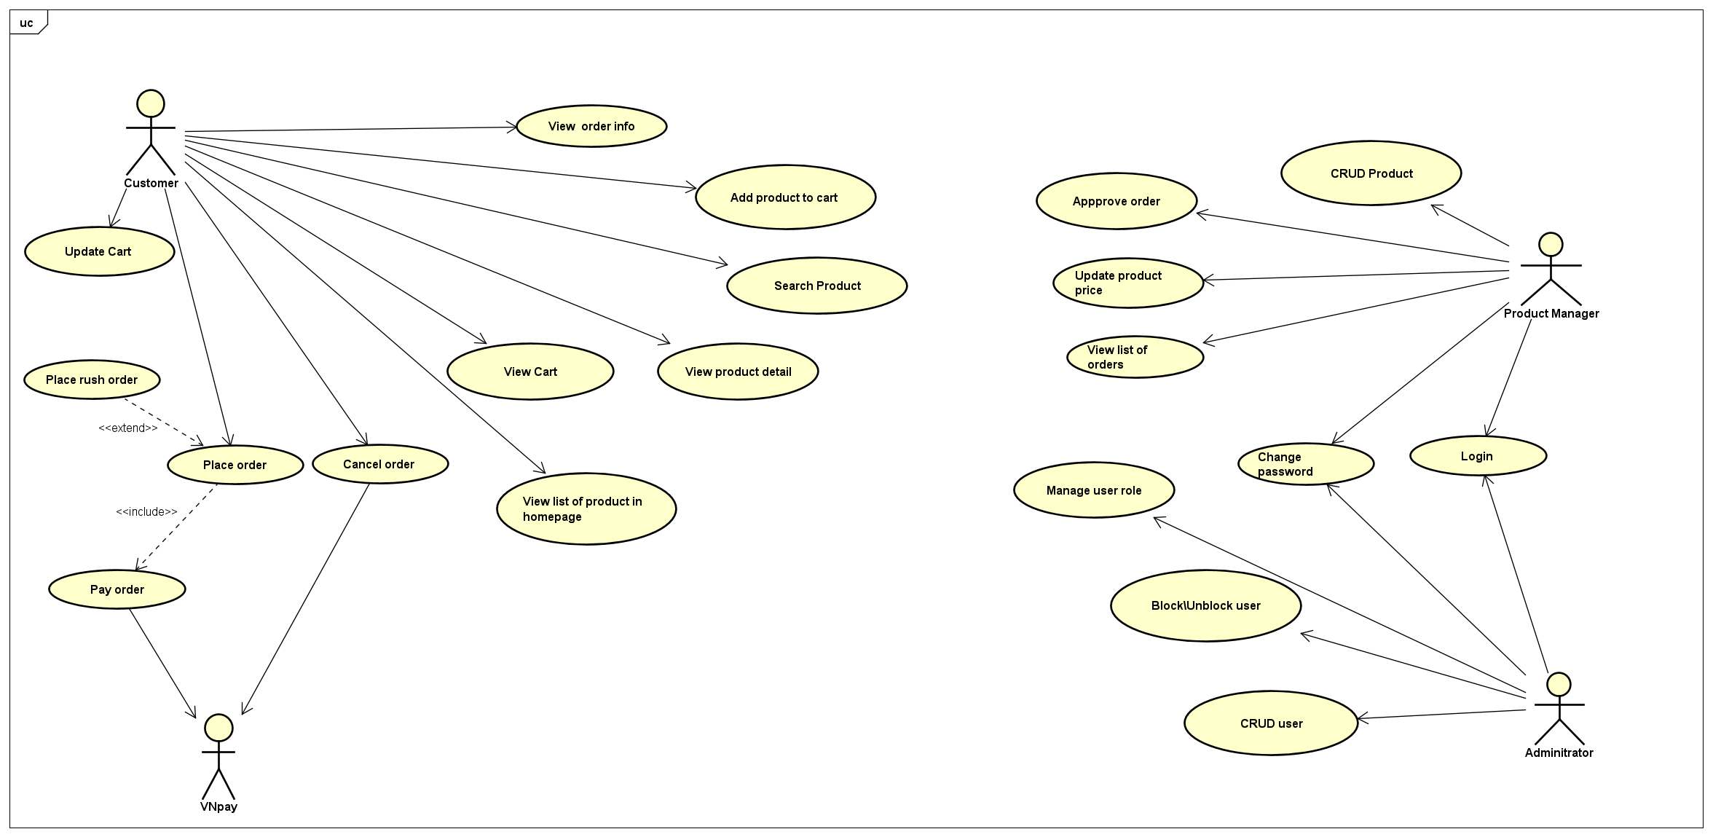

## Business process

# 3 Detailed Requirements

## 3.1 Use case 1

**Use Case “Pay Order”**

1. **Use case code**

UC001

1. **Brief Description**

This use case describes the process of a customer paying for an order within the AIMS e-commerce software.

1. **Actors**
2. **Customer**
3. **VNPay (external payment service)**
4. **Preconditions**
5. Customer has selected products and added them to the cart.
6. Customer has entered or updated delivery information.
7. Customer has reviewed the cart and selected products for purchase.
8. Customer has selected the desired delivery method.
9. Customer has reviewed and confirmed the order.
10. **Basic Flow of Events**
11. Customer selects the "Pay Order" option.
12. The software initiates a check on the completeness and validity of the provided information.
13. Customer selects the payment method (supported by VNPay).
14. Customer provides necessary information as requested by VNPay to complete the transaction. (See table A)
15. The software communicates with VNPay to process the payment.
16. After a successful payment, the software will display the transaction ID, cardholder's name, deducted amount, transaction details, and transaction date and time. (See Table B.)
17. **Input data**

**Table A-Input data of provides necessary information as requested by VNPay**

|  |  |  |  |  |  |
| --- | --- | --- | --- | --- | --- |
| **No** | **Data fields** | **Description** | **Mandatory** | **Valid condition** | **Example** |
|  | Bank account number |  | Yes | Integer greater than 1000000 | 74619911 |
|  | Customer name | Owner’s name of the bank account | Yes | String not include number and special symbol, spaces are allowed | Nguyen Huu Trung Kien |

1. **Output data**

**Table B- Output data of display the transaction ID, cardholder's name, deducted amount, transaction details, and transaction date and time.**

|  |  |  |  |  |
| --- | --- | --- | --- | --- |
| **No** | **Data fields** | **Description** | **Display format** | **Example** |
|  | transaction ID |  |  |  |
|  | cardholder's name |  |  | Do Minh Hieu |
|  | deducted amount |  | Right alignment  Vietnamese currency  (VNĐ)  Vietnamese locale | 1.200.000 VNĐ |
|  | transaction details |  |  |  |
|  | transaction date and time |  | dd/mm/yyyy | 05/10/2023 |

1. **Postconditions**   
   1. The order status is updated to "Pending Processing."   
   2. Transaction information is recorded in the system.   
   3. An email containing order and transaction details is sent to the customer.   
   4. The customer can review or cancel the order using the link provided in the email.

## 3.2 Use case 2

**Use Case “Place Rush Order”**

**1. Use Case Code**

UC004

**2.Brief Description**

This use case describes the interaction between the customer and AIMS when the customer wants to make a rush order delivery

**3.Actors**

User

**4.Preconditions**

Customer chooses rush order option in “Place Order”

**5.Basic Flow of Events**

1. AIMS displays the rush order delivery screen with a list of products that support rush order delivery

2.Customer updates rush order information and chooses products

3.AIMS calculates shipping costs

**6.Alternative flows**

*Table 1 - Alternative flow of events for UC “Pay Order”*

|  |  |  |  |  |
| --- | --- | --- | --- | --- |
| **No** | **Location** | **Condition** | **Action** | **Resume location** |
| 1. | At Step 1 | If the customer cancels the payment transaction |  | Use case ends |
| 2 | At step 3 | The location is not in Ha Noi | Notifies the unsupported delivery for areas outside Ha Noi | 1 |
| 3 | At step 3 | Mising info | Requests customer to fill the missing information | 1 |

**7.Input Data**

*Table 2- Input data of rush order information*

|  |  |  |  |  |  |
| --- | --- | --- | --- | --- | --- |
| **No** | **Data fields** | **Description** | **Mandatory** | **Valid condition** | **Example** |
| 1. | Receiver Name | Name of the receiver | Yes |  | Marie Callender |
| 2. | Phone Number | Number of the receiver | Yes | 10 digits | 0999111222 |
| 3. | Province | Choose from a list | Yes |  | Ha Noi |
| 4. | Address | Shipping address | Yes |  | 12, 34 Alley of Tran Thai Tong street, Cau Giay district |
| 5. | Shipping instruction | Additional request on how should the product be delivered | No |  |  |

**8.Output Data**

**NONE**

**9.Postconditions**

Payment for the order is completed, AIMS system resumes the “Place Order” use case.

# 4 Supplementary specification

## 4.1 Usability

- Allowing new users to easily familiarize themselves.

## 4.2 Reliability

- Operate continuously for 300 hours without failure.

- Resume normal operation within a maximum of 1 hour after an incident.

## 4.3 Performance

- The maximum response time of the software is 2 seconds under normal conditions or 5 seconds during peak hours.

- Serve up to 1,000 customers simultaneously without significantly reducing performance.

## 4.4 Supportability

- Operates 24/7